Write a R program to create a sequence of numbers from 20 to 50 and find the mean

of numbers from 20 to 60 and sum of numbers from 51 to 91.

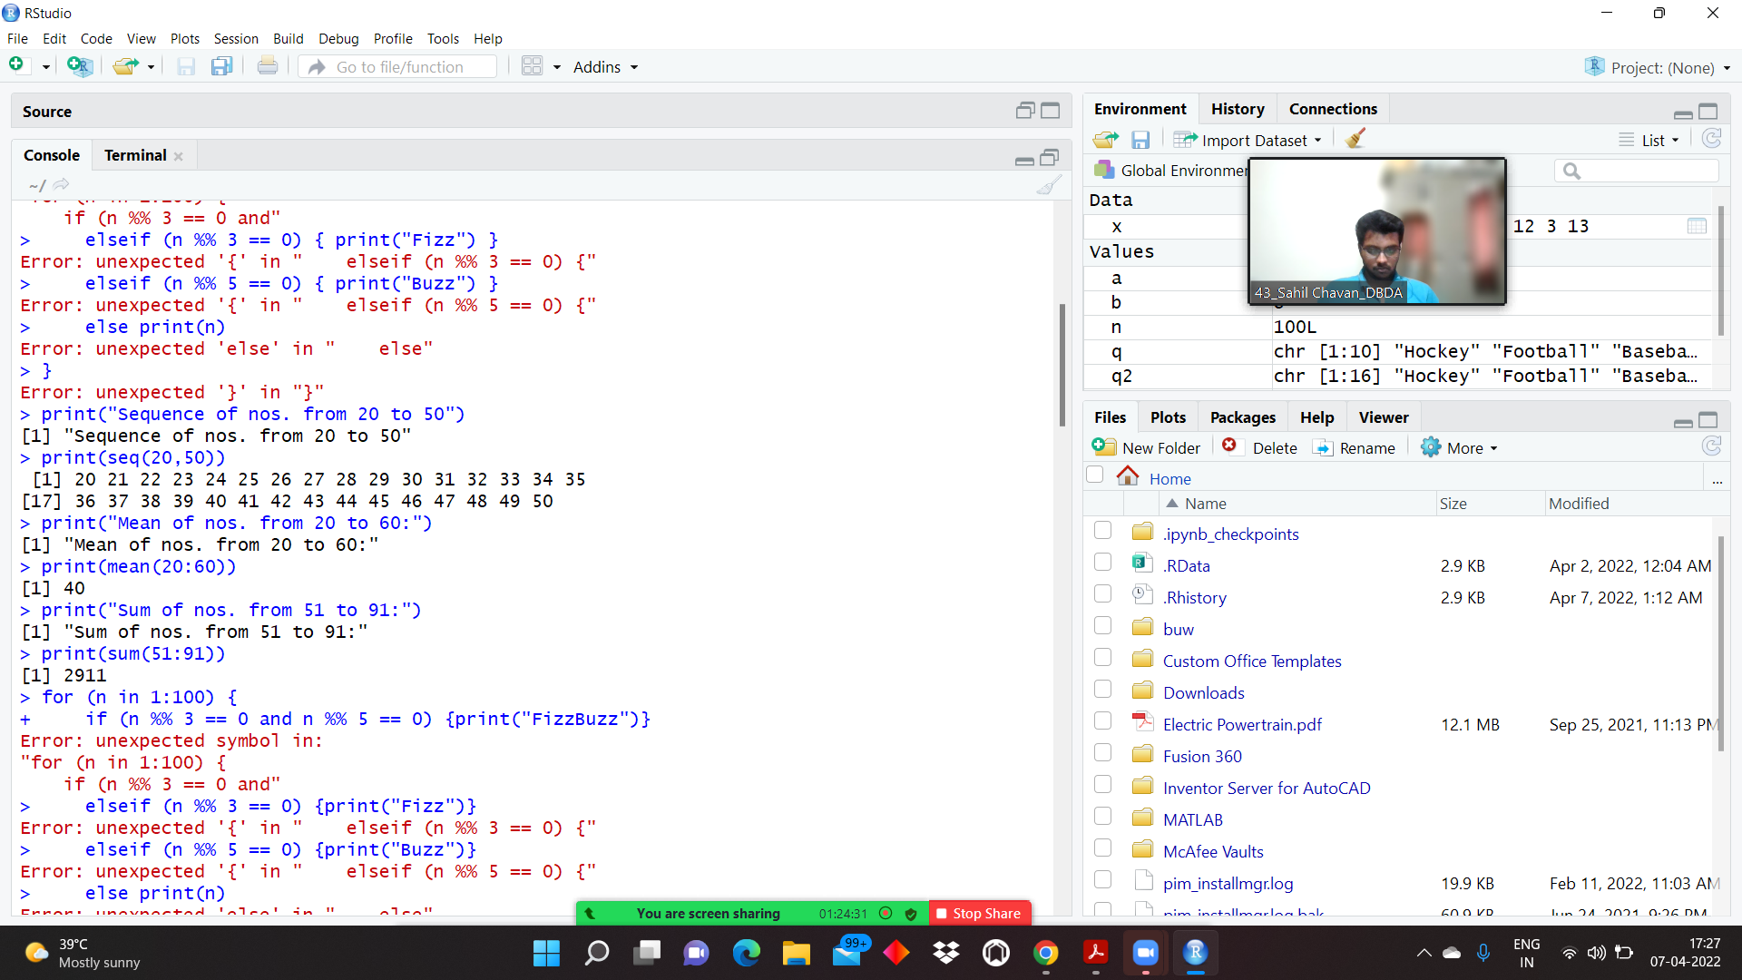

Write a R program to print the numbers from 1 to 100 and print "Fizz" for multiples

of 3, print "Buzz" for multiples of 5, and print "FizzBuzz" for multiples of both.

